VIT UNIVERSITY

APPLICATIONS OF DIFFERENTIAL EQUATIONS

MAT2002

experiment-7

Faculty: Dr. Mellacheruvu Naga Srinivasu slot:L49+L50 venue:SJT319

**NAME: KARANI JASWANTH REG.NO:16BIT0058**

**DATE:22/03/2018**

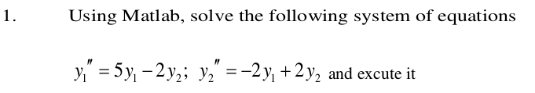

**CODE:**

clc

clear all

close all

syms x1(t) x2(t)

A=input('Enter the co efiicient matrix');

lambda=eig(A)

for i=1:length(lambda)

temp=null(A-lambda(i)*eye(size(A)));

P(:,i)=temp./min(temp);

end

disp('the modal matraix is');

disp(P);

D =inv(P)*A*P;

X = [x1;x2];

Sol1 = dsolve(diff(x1,2) + D(1)*x1 == 0);

Sol2 = dsolve(diff(x2,2) + D(4)*x2 == 0);

disp('The solution of the system diff(X,2)+DX=0 is: ');

disp(Sol1);

disp(Sol2);

disp('The Solution of the given system is: ');

Y = P*[Sol1; Sol2]

**INPUT:**

Enter the co efiicient matrix[5 -2;-2 2]

**continued...**

**OUTPUT:**

lambda =

1

6

the modal matraix is

0.5000 -2.0000

1.0000 1.0000

The solution of the system diff(X,2)+DX=0 is:

C3*cos(t) + C4*sin(t)

C6*cos(6^(1/2)*t) + C7*sin(6^(1/2)*t)

The Solution of the given system is:

Y =

(C3*cos(t))/2 - 2*C7*sin(6^(1/2)*t) - 2*C6*cos(6^(1/2)*t) + (C4*sin(t))/2

C6*cos(6^(1/2)*t) + C7*sin(6^(1/2)*t) + C3*cos(t) + C4*sin(t)

**SCREENSHOT:**

